**PROBLEM DESIGN PHASE-I**

Solution Architecture

|  |  |
| --- | --- |
| Date | 11th October, 2022 |
| Project name | Plasma donation application |
| Project members | 1. Abhishek Kumar Yadav 2. Aman Khemka 3. Jadav Rajveer 4. Ridham Verma 5. Sagar Seth |
| Project mentors | * Industry mentor(s): Sowjanya, Sandeep Doodigani (Mentor 14) * Faculty mentor(s): Dr. E.M Malathy |

* **USE CASE DIAGRAM:**

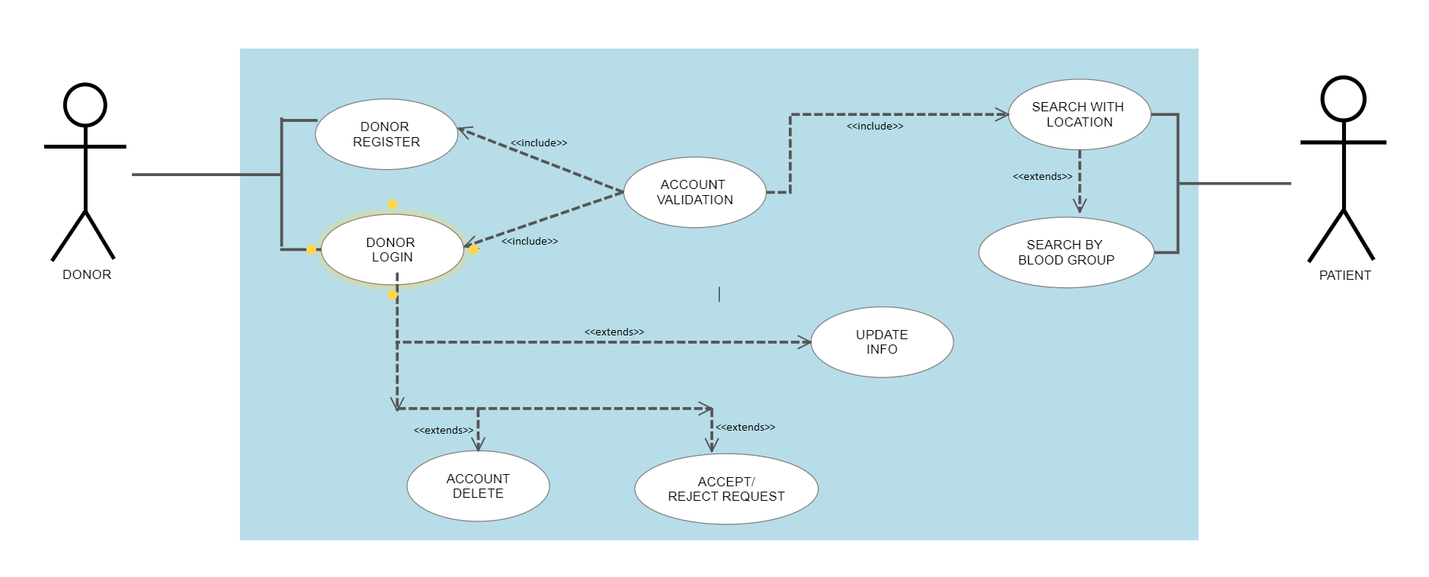

* **CLASS DIAGRAM:**

